Docker complete Step by step process

1)Create a VM on ec2 instance

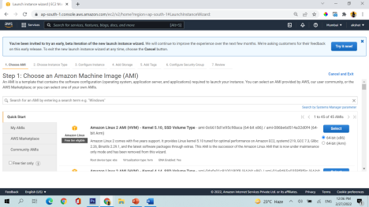Select amazon linux 2 ami

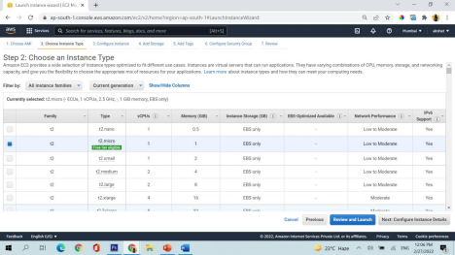Select t2.micro and configure instance details

Add storage

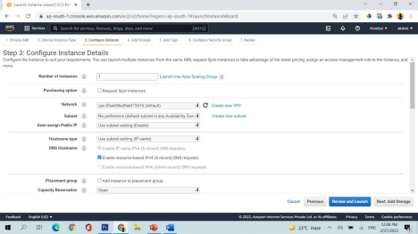

Add tags

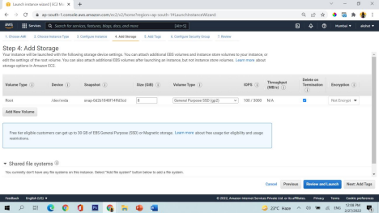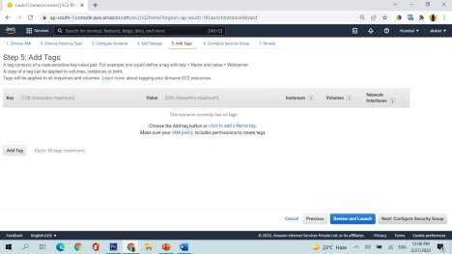Configure security groups

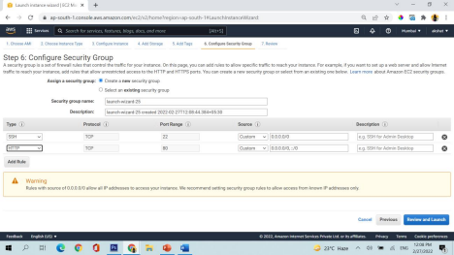Add http and review and launch

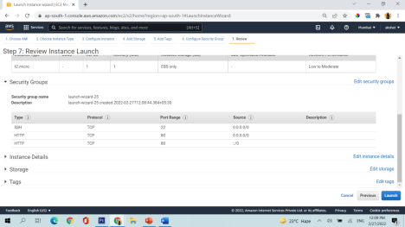Now launch

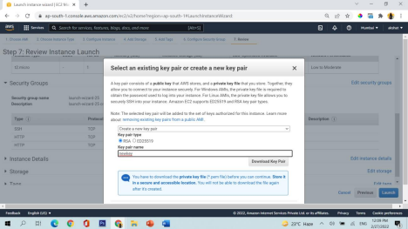Create a new keypair and download it

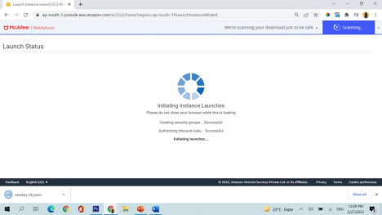launch instance

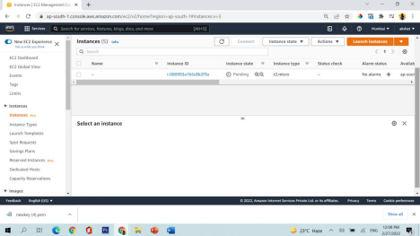See instance is created in pending state

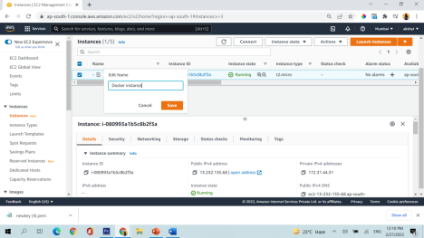give the instance (virtual machine) a name

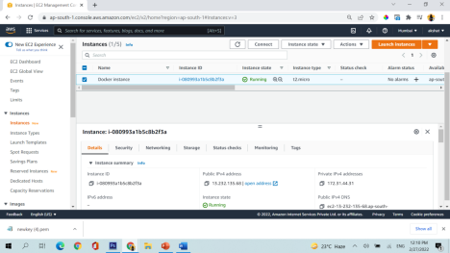Wait for 4-5 mins for machine to go live properly

**2)Connection with the instance (Virtual machine)**

Download a software mobaxterm

(https://drive.google.com/file/d/1y

kG7FmY55jaDYa4IbrHbzSLlSHNbodG/view?usp=sharing) from here

It will look like this

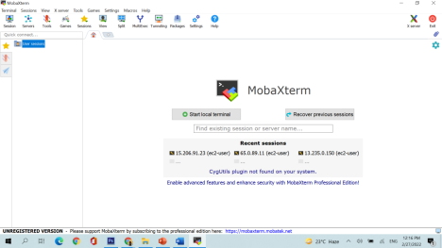

Now click on session and start a new session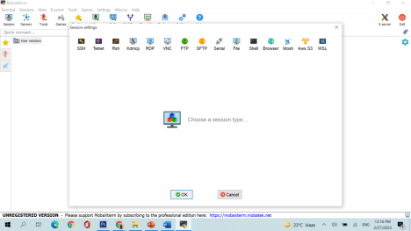

Go to ssh and in remote host put public ip of the machine and tick mark specify username and put ec2-user there

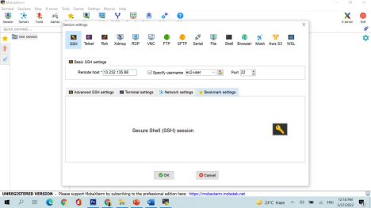

From here you will get the public ip of the machine

Click on Advance ssh setting in mobaxterm

And select use private key and select the key which you have downloaded while creating machine



Successfully connected



3)Now put these commands in the machine for Linux machine

➢sudo su

➢yum install docker -y (this will install docker in your machine)

➢yum update -y (update all the softwares in your machine)

➢which docker (tells you the location where docker is installed)

➢ docker - - version (tells you the docker version installed in your linux machine)

➢ ➢service docker status

➢service docker start (start docker in your machine) ➢docker images

➢docker ps (shows which all dockers are running) ➢ docker ps -a (shows which all dockers are created)

4)Now go to google chrome



Search ubuntu

Click on ubuntu https://hub.docker.com/_/ubuntu

➢docker run -it ubuntu /bin/bash (put you inside the docker container)

➢ls

➢cat /etc/os-release (here the output would be ubuntu)

➢exit (stop and exit from container)

➢docker images

➢docker run-it ubuntu /bin/bash

➢ exit

➢docker ps -a

➢docker ps

➢docker start <<name of the docker which you will get from docker ps -a command>>

5)Now put these commands in the machine for Ubuntu machine

➢sudo su

➢apt update -y

➢apt install docker.io -y

➢docker –version

➢service docker start

➢service docker status

➢docker images 🡪show u all images which are presented in docker registry

➢docker pull node

➢docker image 🡪 It will the docker image which is installed

➢docker pull node: lts

➢docker images

➢docker image rm node:lts 🡪It will delete the docker image

➢docker images

➢docker run -it ubuntu /bin/bash 🡪 To create a container

Docker- To communicate with docker engine.

Run- execute the docker container.

It- interactive terminal 🡪 get inside the container.

Ubuntu- image

Bin/bash- bash terminal

➢ls -> it’ll give all list of file present in container

➢touch file

➢ls 🡪 make sure file should present in the container

➢exit🡪 will stop the container and come out of the container

➢press ctrl P & ctrl Q --> it will save the process and quit the process

➢docker ps -a 🡪 to get all list of containers

Ps – list all the process.

➢docker run -it --name subbaramcontainer ubuntu /bin/bash🡪 creating new container with name

➢exit 🡪 come out of the container

➢docker ps -a 🡪 list of containers

➢docker rm “container ID” or “name”

➢docker attach “container ID” or “name” 🡪 To get into the container (Unable to get in until/unless container started)

➢docker start subbaramcontainer 🡪 container is going to start

➢docker ps 🡪 it’ll show the container are in progress

➢docker attach subbaramcontainer 🡪 to get in container

➢docker start